**Geographical Information Systems**

**Assignment 2**

Student Name: Hassan ragab hassan bakr

Student ID:20190177

Group No.: S4

**Objective**

The objective of this assignment is to identify an area "أرض فضاء"in which to build new high school in El Dokki District.  This new school must be in an area

1. not within 100 meters of the existing schools

solution

get schools in dokki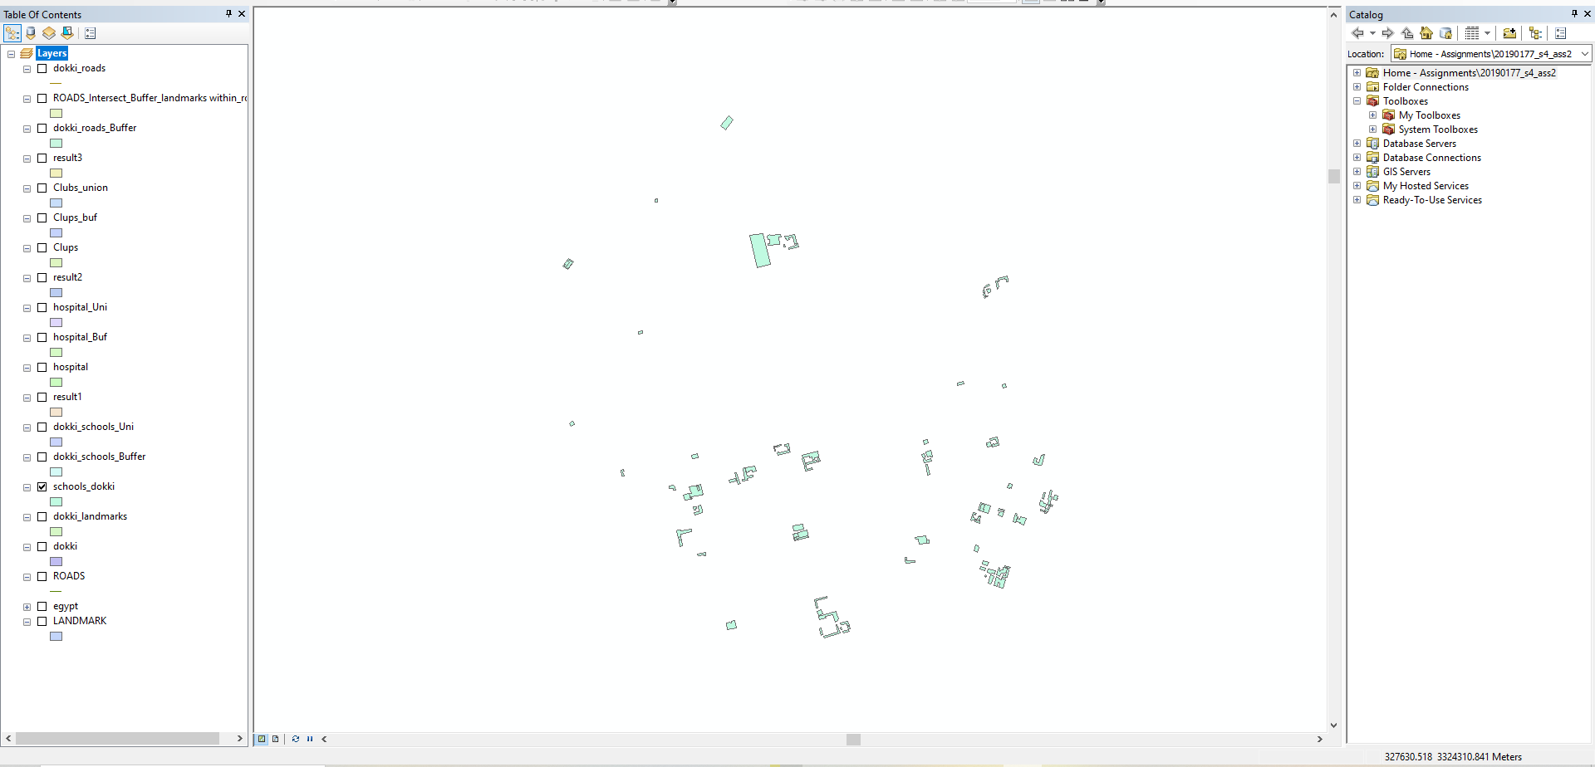

make buffer to the schools in dokki within 100 m

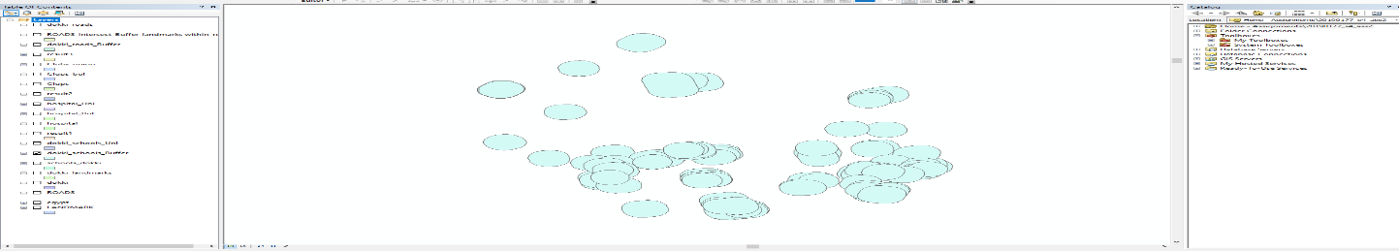

get the union between (dokki_schools and dokki_schools_buf)

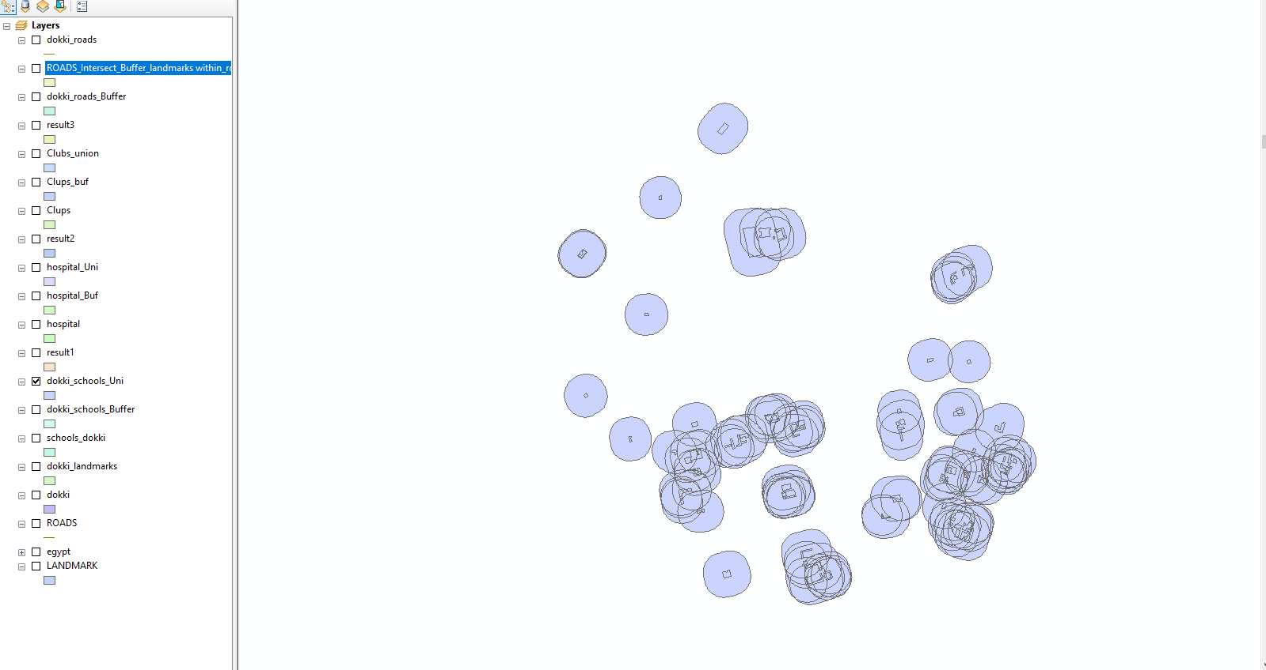

Then erase between(dokki_landmaarks and the union image above)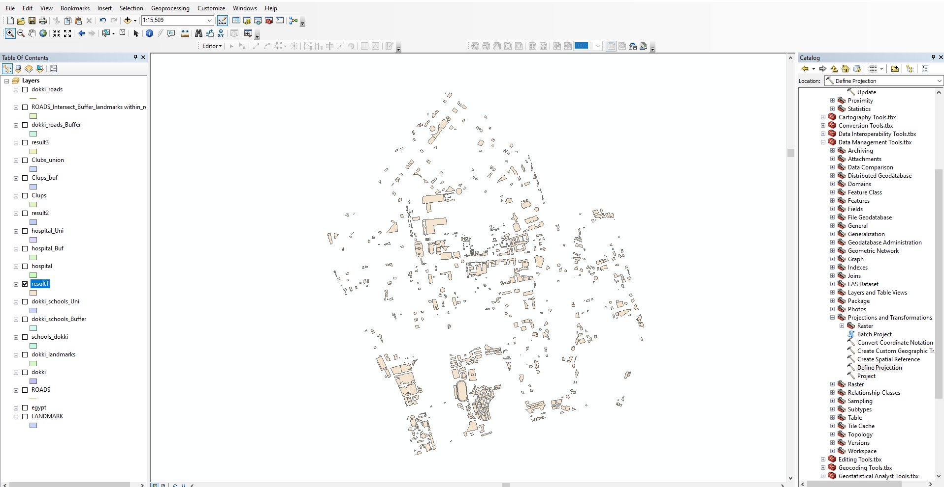

1. not within 500 meters of the existing hospitals

get hospital from the result in step 1 above

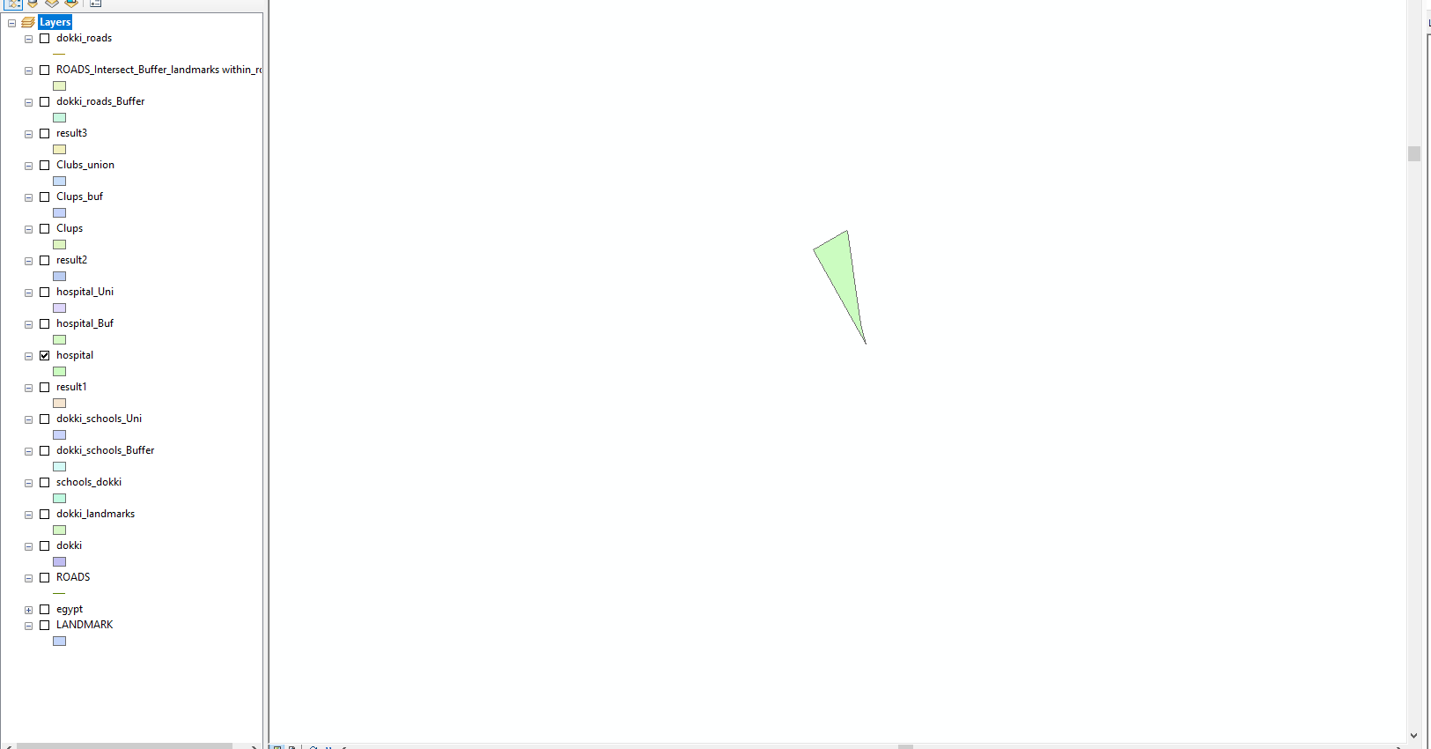

Make buffer for hospitals in dokki within 500m

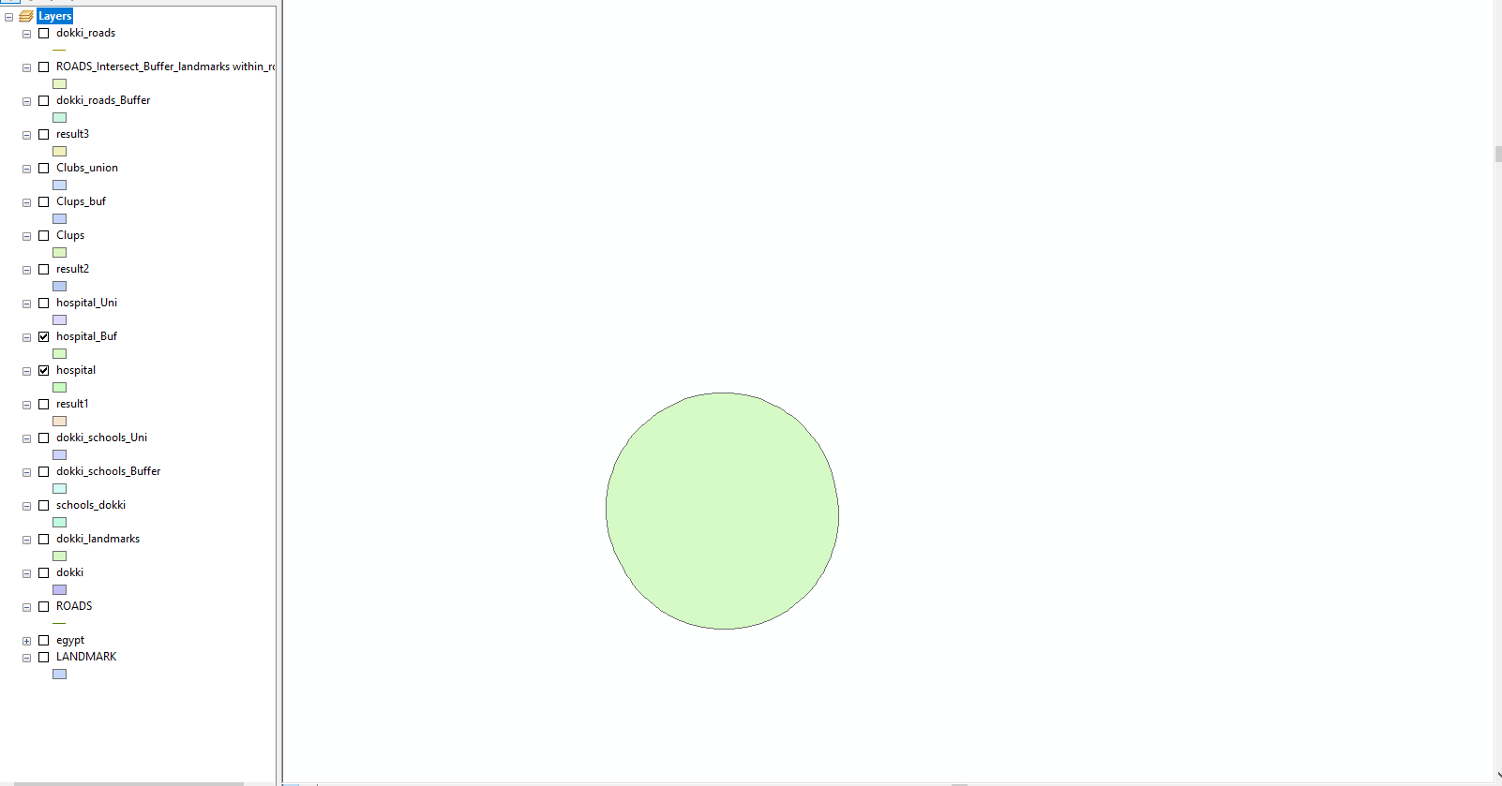

Union between buffer for hospitals and hospitals itself

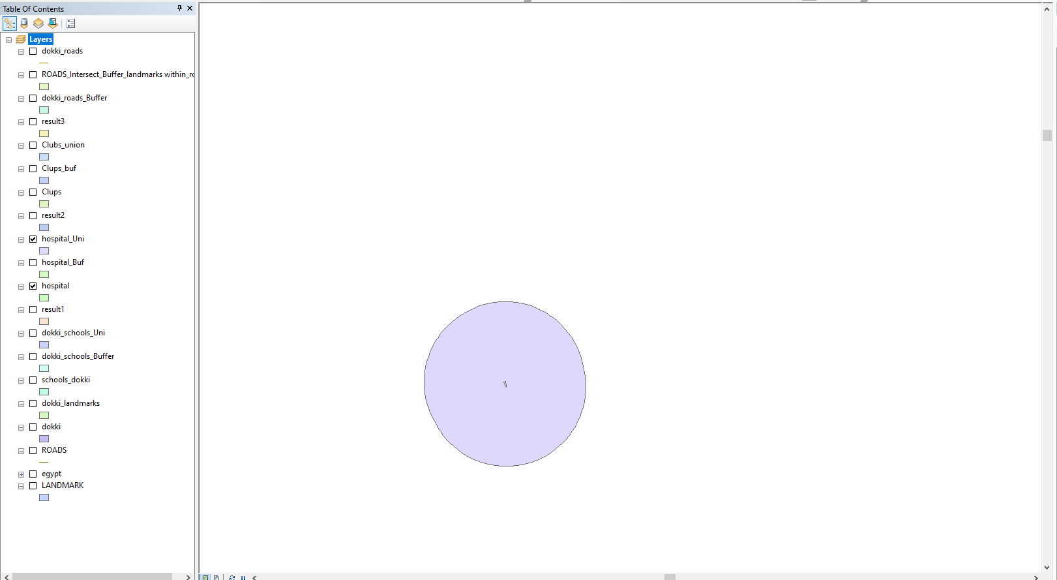

Erase between the uoinion and result from step1

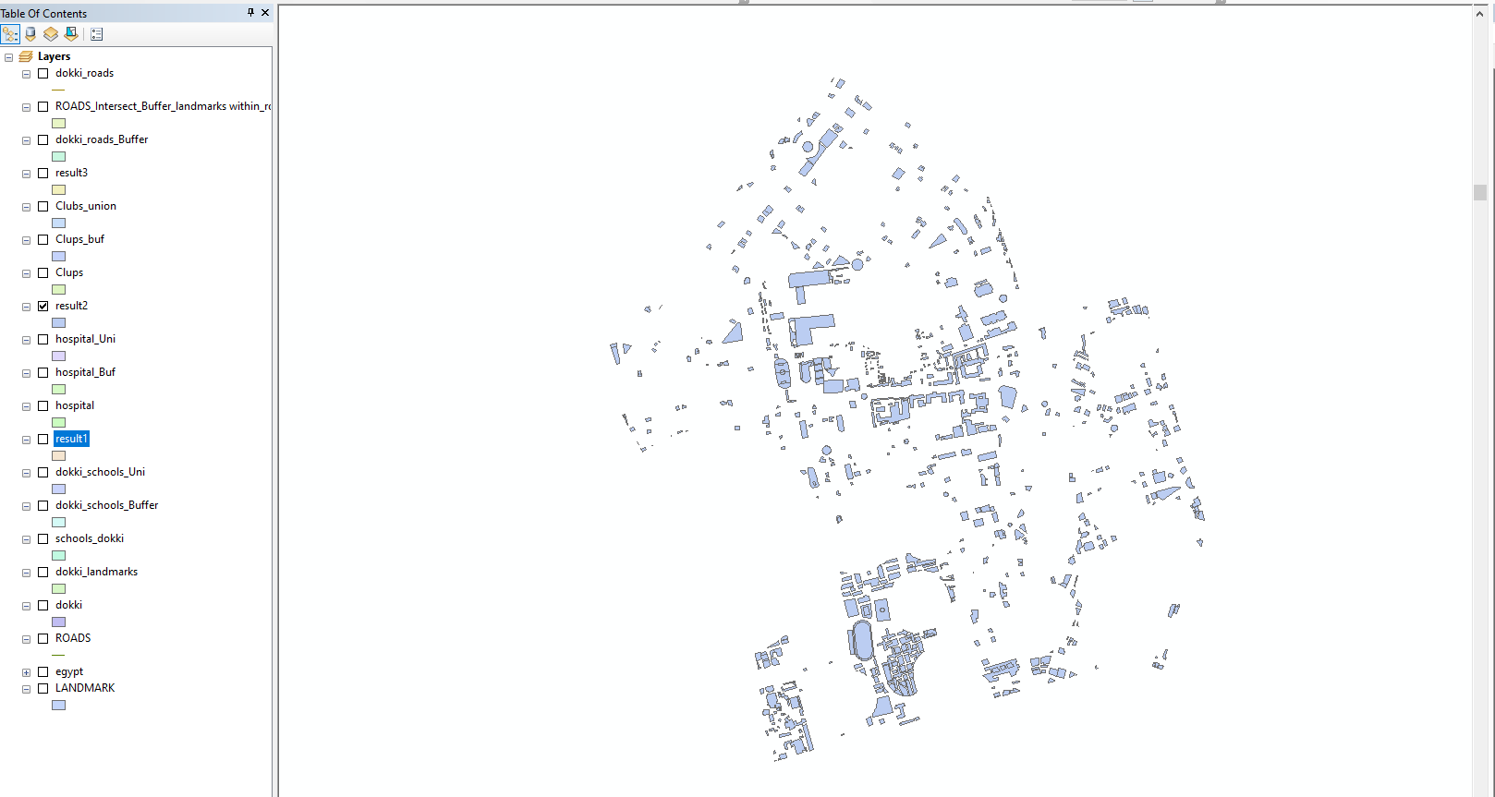

1. not within 500 meters of the existing Clubs

get all clubs from result 2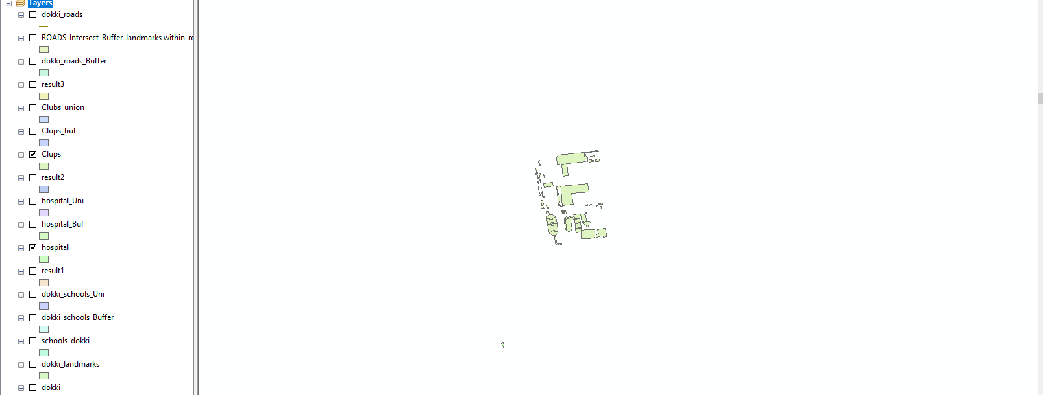

create buffer for hospitals in image above

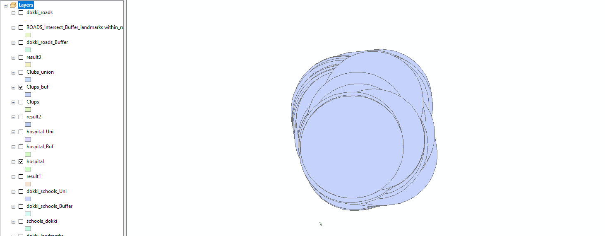

Get union from all clubs and the buffer for clubs within 500

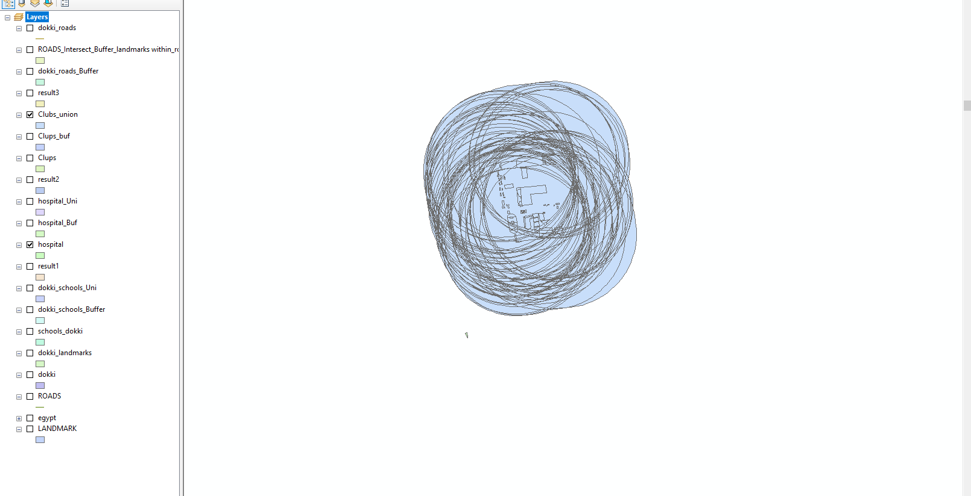

Erase between union and result 2

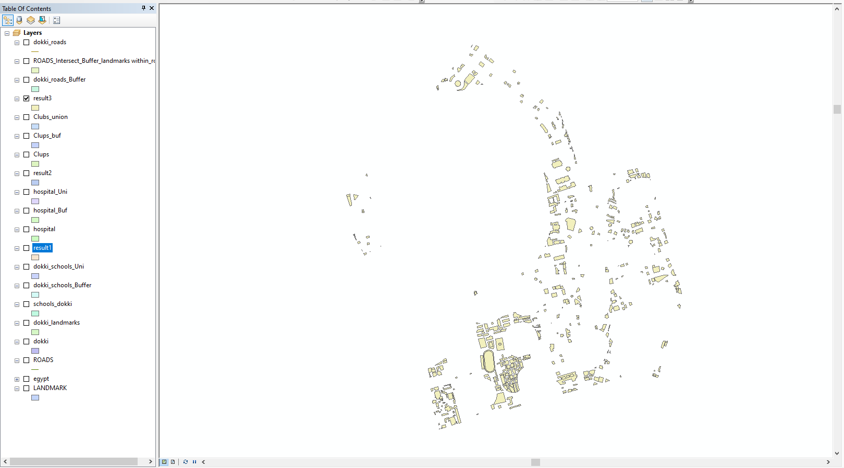

1. within 50 meters of a street

get dokki roads from the intersection between (landmarks _in_dokki and roads layer)

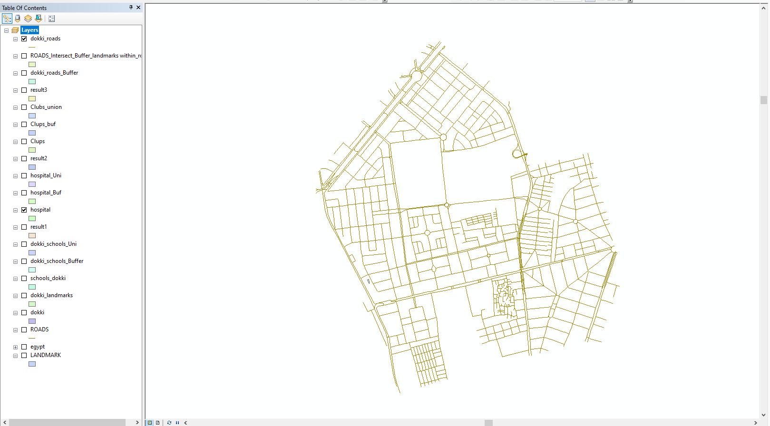

Make buffer for roads within 50m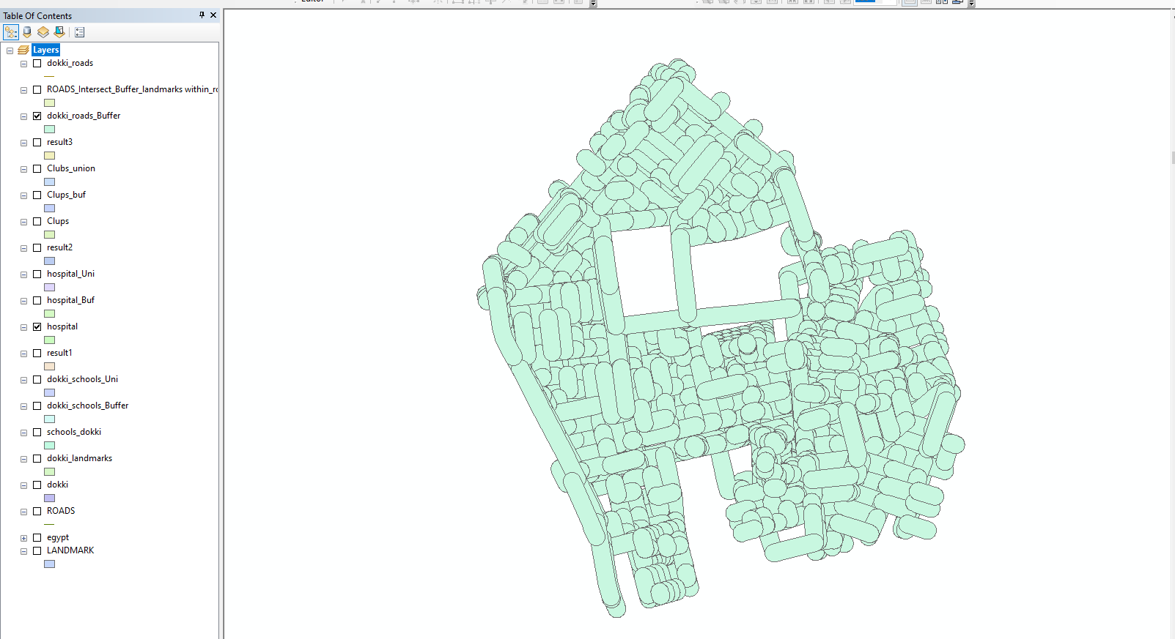

Get the intersection between roads in dokki and the buffer that have landmarks

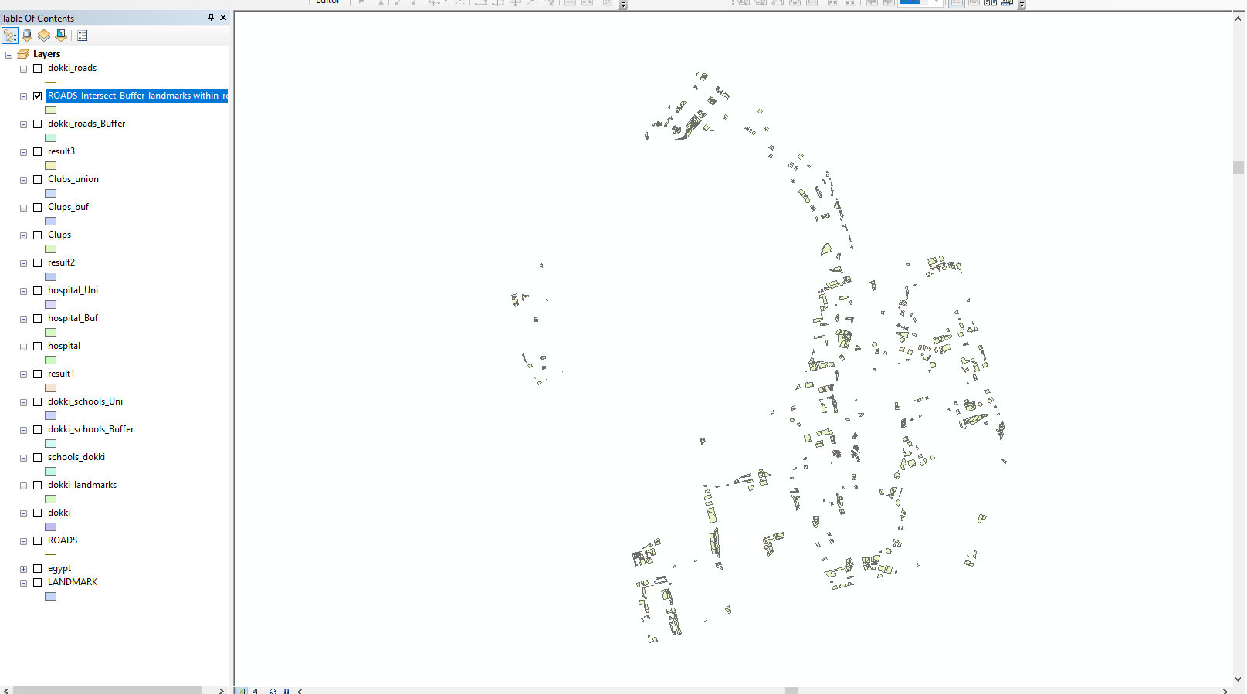

1. with an area of at least 5,000 square meters

